**Question 1**

Explain why a firm with market power faces a downward sloping demand curve, while a perfectly competitive firm faces a horizontal demand curve.

**Answer:**

A perfectly competitive firm has many competitors that are willing to sell identical products at the market equilibrium price. The competitive firm can call all it wants at the market price but will sell nothing if it charges any price above the market price. Therefore, it faces a perfectly elastic, or horizontal demand curve, even though the market demand curve is downward sloping.

A firm with market power is “large” relative to the size of the market and has the ability to increase its price without losing all of its customers. Therefore it faces a downward sloping demand curve. In the case of a monopolist, the demand curved faced by the firm is the same as the market demand curve.

**Question 2**

Suppose that Cary’s Car Wash is the only car wash in its suburb and faces the following demand schedule for car washes per hour.

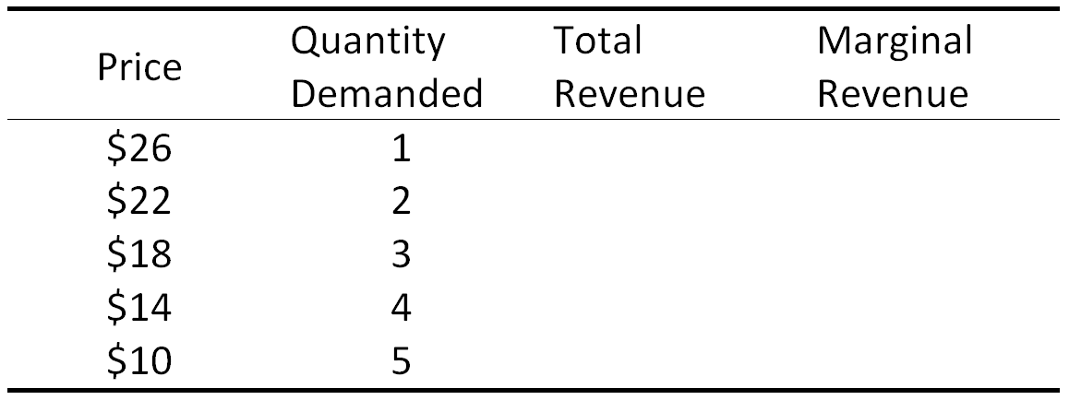

A. Complete the table.

B. If the Cary’s marginal cost is constant and equal to $10, what is its profit-maximising level of output and price?

C. Calculate Cary’s profit, assuming that she does not incur any fixed costs.

D. Suppose instead that there were many nearby car washes with the same marginal cost. What would be the equilibrium level of output and price?

**Answer:**

A.

|  |  |  |  |
| --- | --- | --- | --- |
| Price | Quantity Demanded | Total Revenue | Marginal Revenue |
| $26 | 1 | $26 | $26 |
| $22 | 2 | $44 | $18 |
| $18 | 3 | $54 | $10 |
| $14 | 4 | $56 | $2 |
| $10 | 5 | $50 | $-6 |

B. MR=MC Price=$18 Q=3

C. Profit=Total Revenue - Total Cost=$54 - 3*$10=$24

(Because Cary’s marginal cost is constant, her Average Variable Cost is also constant and equal to $10. Because she has no fixed costs, this is also her Average Total Cost. )

D. In a competitive market, firms will undercut one another until the market price is equal to the marginal cost of the last unit produced. So, P = $10 and Q = 5.

**Question 3**

A monopolist has the following costs and demand for its product.

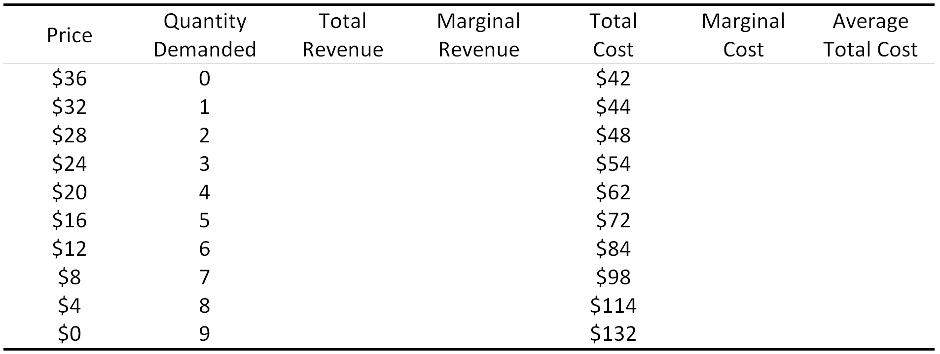

A. Complete the table.

B. On a single graph, plot the monopolist’s demand curve, marginal revenue, marginal cost and average total cost.

C. Label the area of the graph which corresponds to the monopolist’s maximum amount of profit.

D. Use your graph to explain why a monopolist (that cannot engage in price discrimination) will typically produce less than the socially optimal quantity.

**Answer:**

A.

|  |  |  |  |  |  |  |
| --- | --- | --- | --- | --- | --- | --- |
| Price | Quantity Demanded | Total Revenue | Marginal Revenue | Total Cost | Marginal Cost | Average Total Cost |
| $36 | 0 | $0 | -- | $42 | -- | -- |
| $32 | 1 | $32 | $32 | $44 | $2 | $44 |
| $28 | 2 | $56 | $24 | $48 | $4 | $24 |
| $24 | 3 | $72 | $16 | $54 | $6 | $18 |
| $20 | 4 | $80 | $8 | $62 | $8 | $15.5 |
| $16 | 5 | $80 | $0 | $72 | $10 | $14.4 |
| $12 | 6 | $72 | $-8 | $84 | $12 | $14 |
| $8 | 7 | $56 | $-16 | $98 | $14 | $14 |
| $4 | 8 | $32 | $-24 | $114 | $16 | $14.25 |
| $0 | 9 | $0 | $-32 | $132 | $18 | $14.67 |

B.

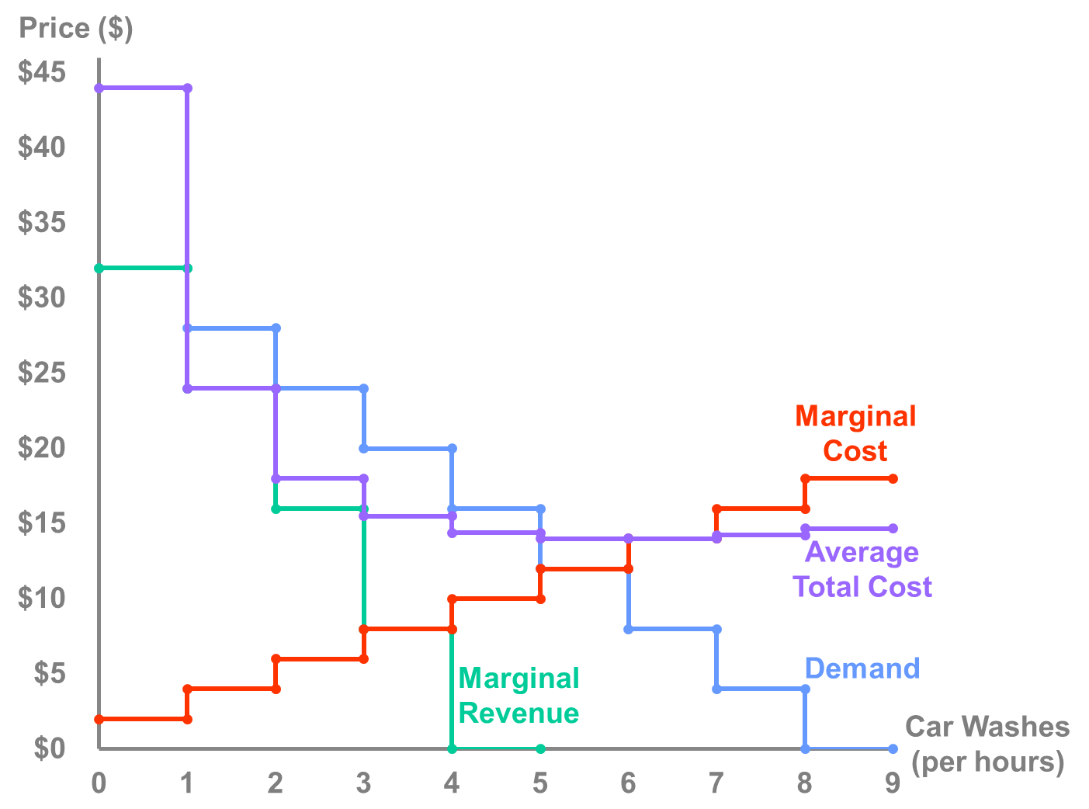

C.

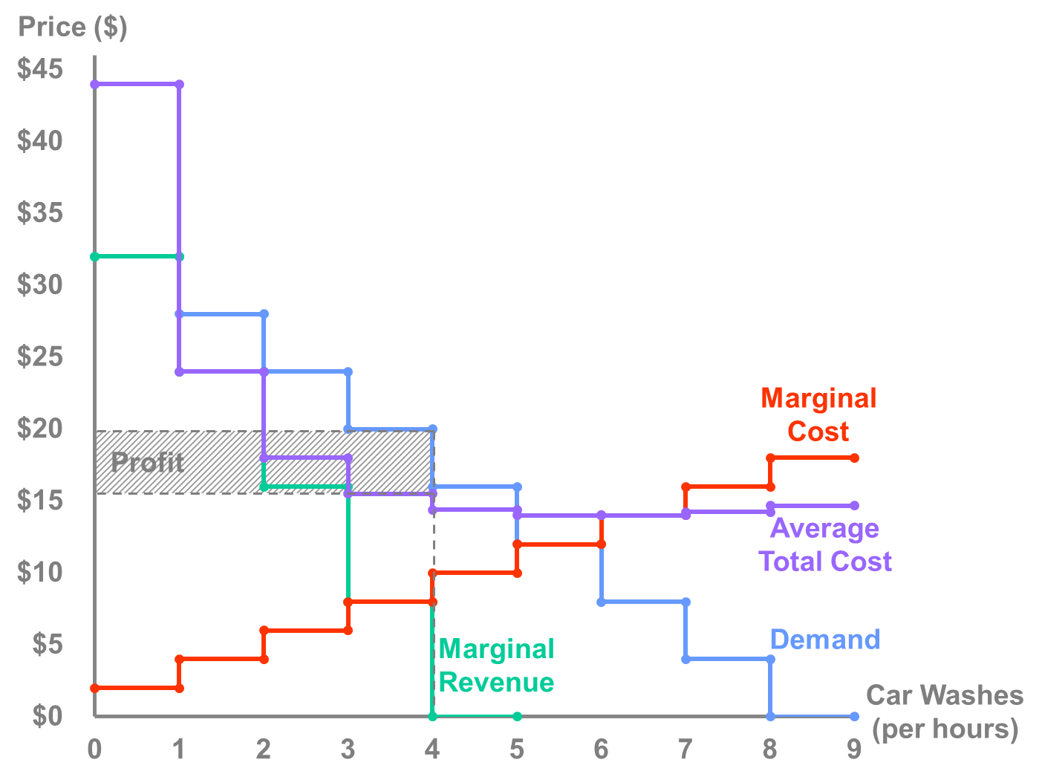

The monopoly’s profit is equal to (Price – ATC) x Quantity. It is maximised by producing the quantity for which MR = MC. Thus, the monopolists maximum profit is area of the rectangle shown.

D. The socially optimal quantity is amount for which P = MC, because this is the point at which the last buyer’s reservation price (the marginal benefit to society) is equal to the marginal cost of producing the last unit. This occurs where the demand and MC curves intersect.

The monopolist produces less than this quantity because its profit is maximised when MR = MC, because this the point at which the marginal benefit to the monopolist is equal to marginal cost of producing the last unit. The monopolist’s MR is not equal to the price because the monopolist realizes that to sell more its good it must reduce the price that it charges everyone.

Another way to understand this is that the monopolist takes into account all the costs of producing the good but not all of the benefits because it only cares about its own revenues and not the consumer surplus generated by producing each additional unit.

**Question 4**

Consider a monopolist that faces the following demand, marginal revenue, marginal cost, and average total cost curves.

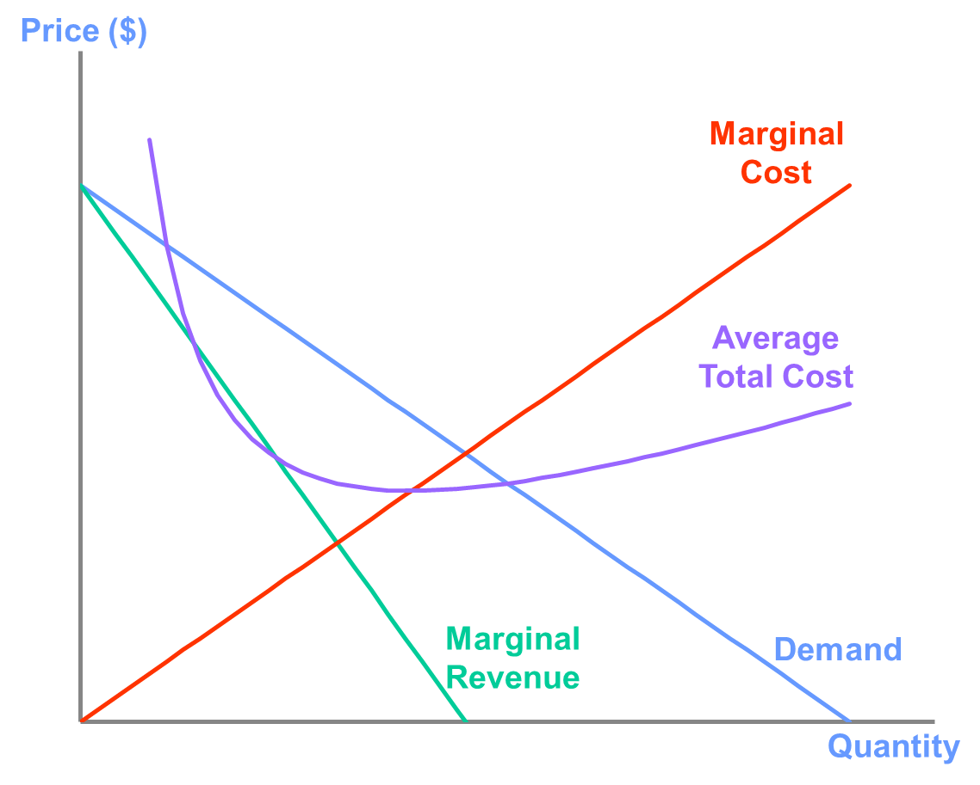

A. Explain why the marginal revenue curve lies below the demand curve.

B. Illustrate on the graph the region the represents the firm’s maximum amount of profit.

C. Illustrate on the graph the region the represents the deadweight loss cause by the monopolist not producing the socially optimal amount of its product.

**Answer:**

1. Because a firm with market power faces a downward sloping demand curve, it can only attract more customers by lowering its price. This means that the marginal revenue from selling an additional unit is less than the price because the price must be lowered for every unit the firm sells, not just the last unit.

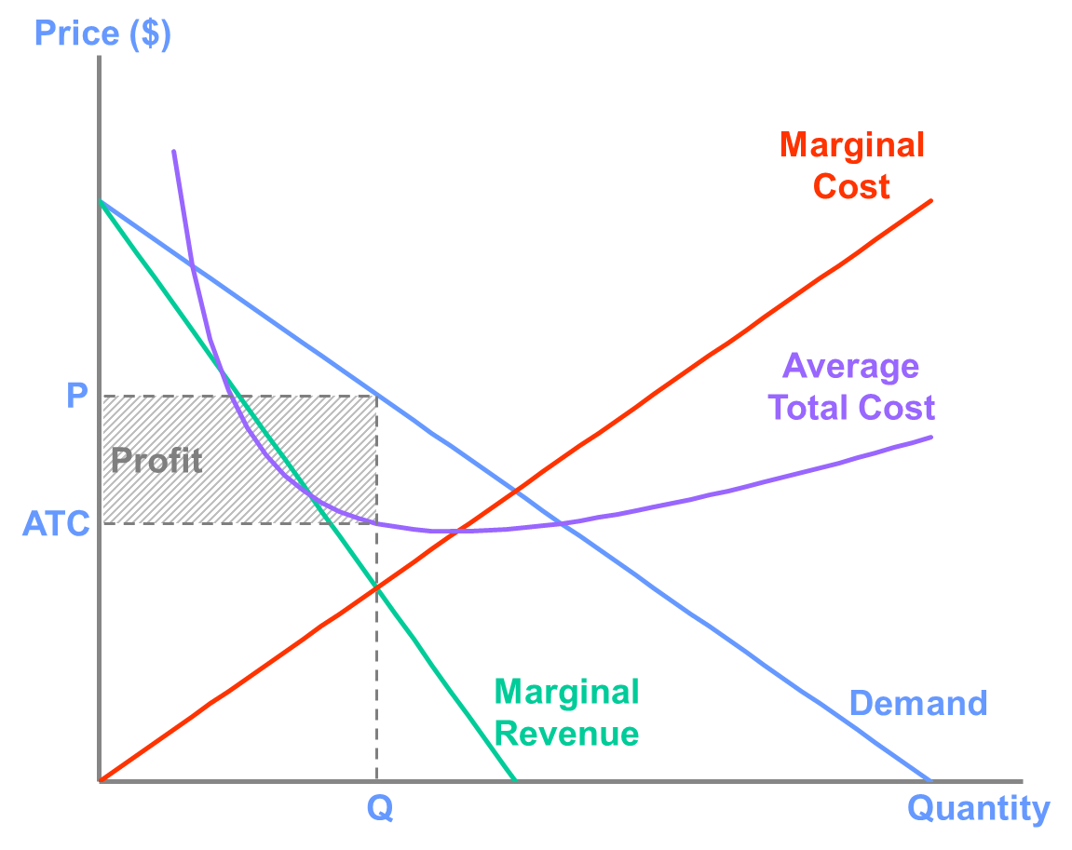

C. The deadweight loss is the area of the triangle between the demand and marginal cost curves for the distance between the profit-maximising monopoly quantity and socially efficient quantity (Q*).

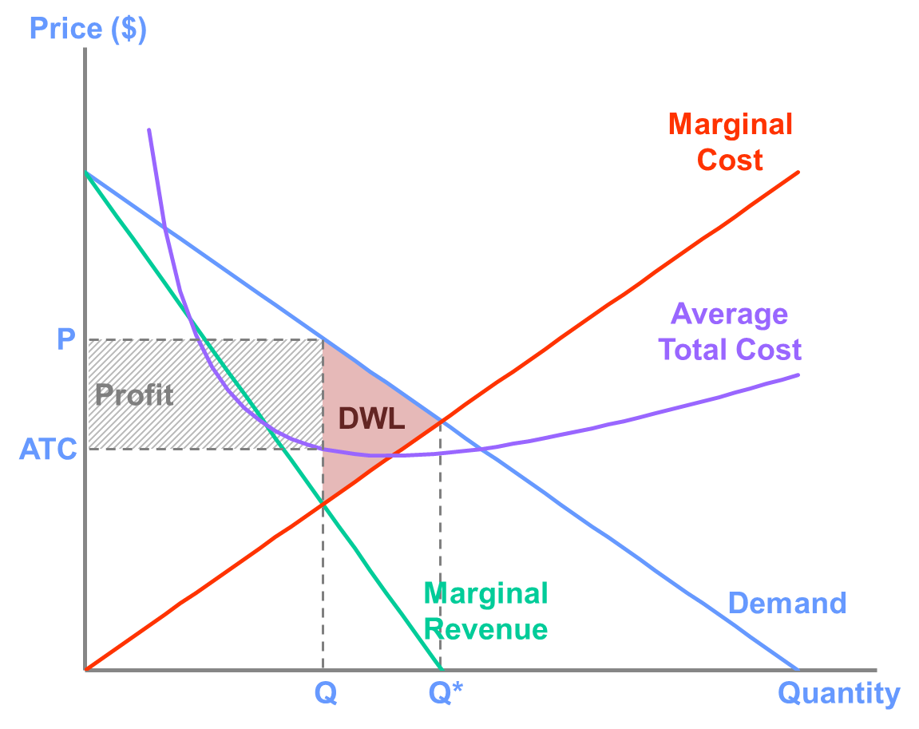

**Question 5**

Ted’s Tunnels has been given permission by the New South Wales government to build a tunnel under Sydney Harbour and charge a toll for vehicles that pass through it. They estimate that the tunnel will cost $2 billion to build and maintain over its lifetime but that the additional cost of allowing cars to use the tunnel is zero. Assume that the tunnel will function for 30 years before needing to be entirely replaced.

The following is the demand schedule for motorists using the tunnel:

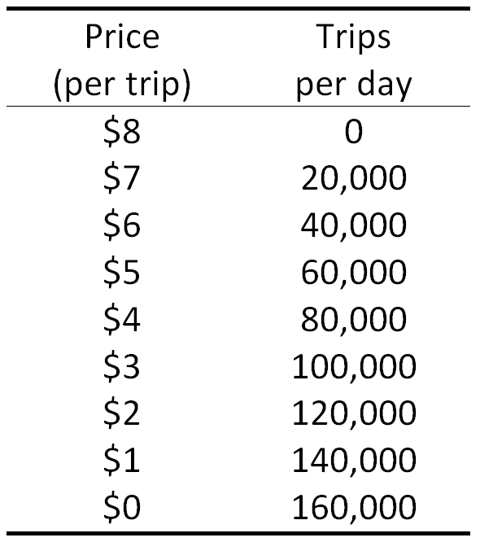

A. What would be the profit-maximising toll? If they are allowed to charge this toll, should Ted’s Tunnels build the tunnel?

B. What toll would maximise total surplus? If they were required to charge this toll, would Ted’s tunnels build the tunnel?

C. What is a policy that the government could institute that would increase total surplus compared to the profit-maximising scenario? Are there any other problems associated with this policy? (Assume that the policy must be decided before the tunnel is built.)

D. Can you think of a reason why the government would not simply allow multiple tunnel-building companies to build tunnels and compete with one another, given that competitive markets are known to maximise total surplus?

**Answer:**

To answer this question it is useful to calculate the marginal revenue and average total cost  of the tunnel. Because the tunnel will operate for 30 years, ATC = $2 billion/(30 x 365 x Trips per day).

[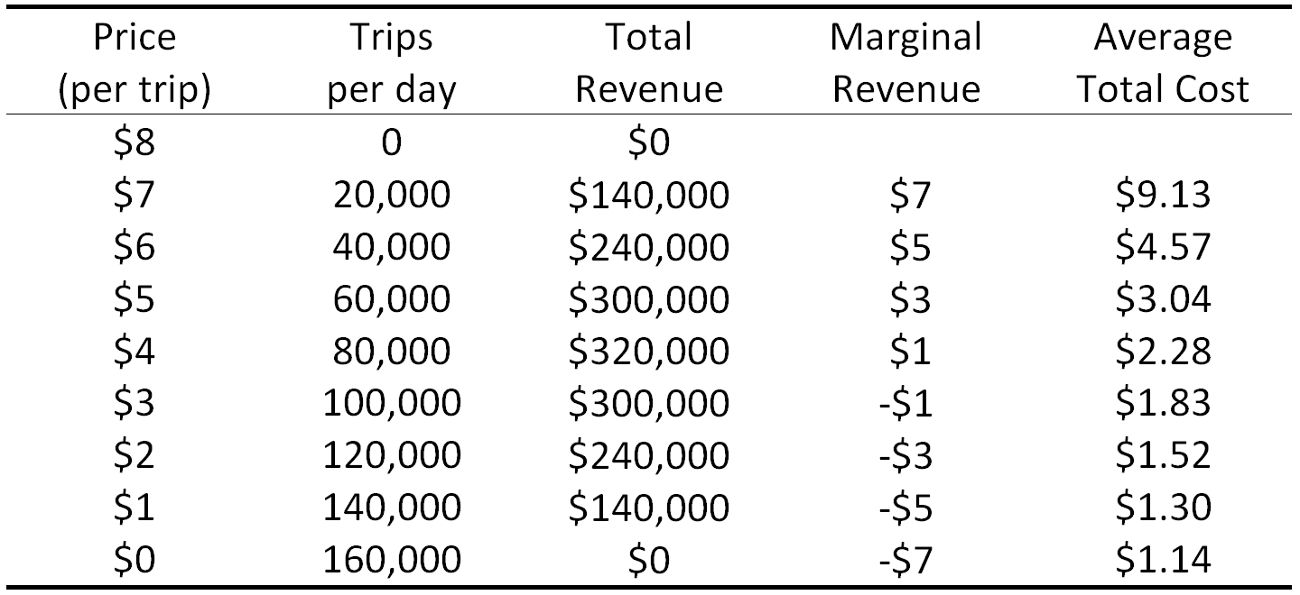](http://lionsheartstudios-publishing.com/unsw/wp-content/uploads/sites/17/2016/03/Ch7_Q5_Ans_Table1.png)

****A.****

Because the marginal cost is zero, Ted’s Tunnels should lower the toll (increasing the number of cars that use the tunnel) as long as marginal revenue is positive. So, the profit maximising toll is $4.

At this toll, the price is greater than average total cost, so it is profitable to build the tunnel.

****B.****

Total surplus is maximised when the marginal benefit to society equals the marginal cost. Since the marginal cost is zero, total surplus will be maximised if price (and thus the marginal consumer’s reservation price) is equal to zero.

At this price, Ted’s Tunnels will make a loss, so it will not be willing to build the tunnel.

****C.****

There are many policies the government could use to increase total surplus. However, it cannot force Ted’s Tunnels to charge a price equal to its marginal cost because then the bridge will not be built.

The government could force Ted’s Tunnels to use Average Cost Pricing, which would mean setting the price to $1.30 (. Two problems with this policy are that 1) the price is still above the socially optimal price, and 2) if Ted’s Tunnels know that their profit will not change regardless of the cost of building and maintaining the tunnel, then they will have no incentive to keep costs low, so the cost (and subsequent regulated price) is likely to exceed the estimate.

The government could also pay to construct the tunnel. However, this requires raising taxes, which typically lowers total surplus, in other markets.

A third option is for the government to set the toll above average total cost (but less than the monopoly price) and allow Ted’s Tunnels to keep the profits. In this case, the price is still above the socially optimal level, but it ensures that the monopoly still has an incentive to reduce costs as much as possible.

****D.****

In this case, providing roads across the harbour is an example of “natural monopoly” because a large fixed cost (building the tunnel) and small marginal cost (maintaining the tunnel). As a result, it is unlikely to be profitable for a firm to enter the market and build a second (or third, or fourth) tunnel. It would also be inefficient to build multiple tunnels if one is able to carry all of the vehicles that would use the tunnel.

**Question 6**

Suppose that there is one movie theatre in a town, with a marginal cost of admitting one extra person to a movie constant and equal to $2. The owner knows that the demand schedules for movie tickets by students and non-students are the following:

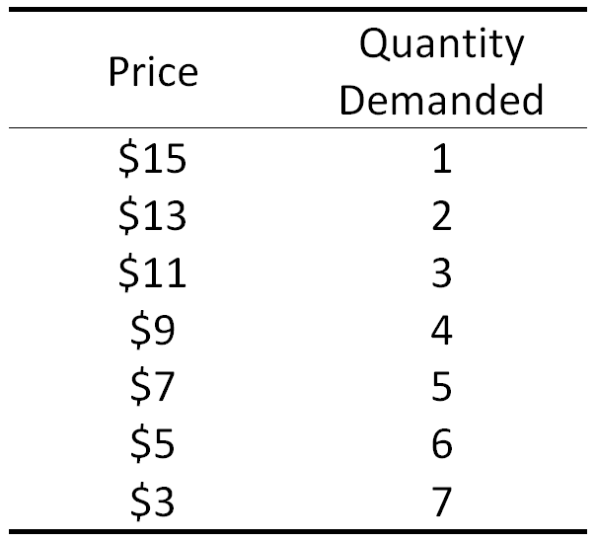

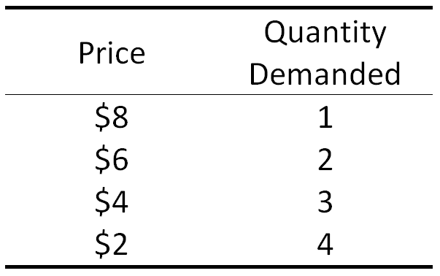

A. Suppose that there is no way to distinguish students from non-students. What is the maximum profit the theatre can earn? (Hint: You will have to find the total market demand.)

B. Suppose that the theatre can identify students by asking to see a student I.D. What is the maximum profit the theatre can earn?

C. In which scenario is total surplus greater? What about consumer and producer surplus?

D. Now, suppose that the theatre can engage in first-degree price discrimination. Are consumer, producer, and total surplus greater or less than the case with no price discrimination.

**Answer:**

****A.****

Since the theatre cannot distinguish between groups, they must treat them as a single group. The table below combines the demand from the groups and calculates total and marginal revenue.

[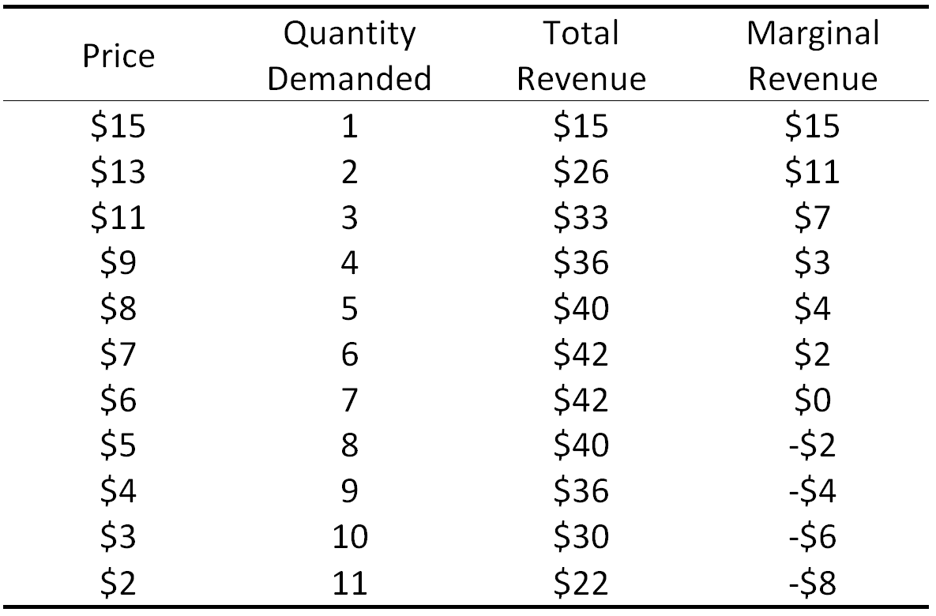](http://lionsheartstudios-publishing.com/unsw/wp-content/uploads/sites/17/2016/03/Ch7_Q6_Ans_A_Table1.png)

To maximise its profit, the theatre will want to admit more customers as long as marginal revenue is greater than $2, so it will set the price to $7 and admit 6 customers. Therefore its profit will be $42 – 6x$2 = $30.

****B.****

If the theatre can distinguish between the groups, it can charge a different price to students and non-students. In this case, it can consider them to be two different markets.

****Students****

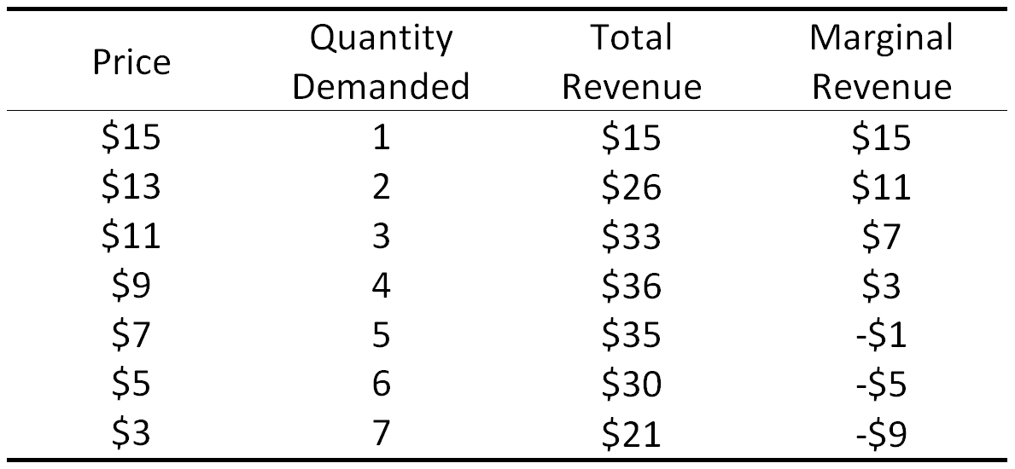

****Non-Students****

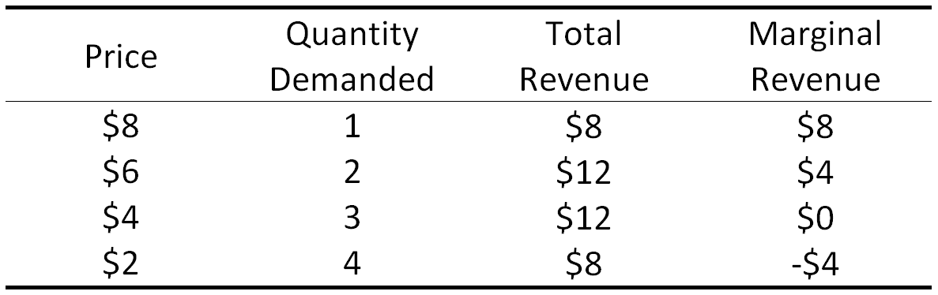

So, the theatre will charge $9 to non-students, and $6 to students. Total profit will be ($36 – 4x$2) + ($12 – 2x$2) = $36.

****C.****

Because we are dealing with a discrete number of customers and units of output, we can just add up the surplus for each. In the first case, consumer surplus is

($15 + $13 + $11 + $9 + $8 + $7) – (6x$7) = $21,

and producer surplus is

6x($7 – $2) = $30.

In the second case, consumer surplus is

($15 + $13 + $11 + $9) – (4x$9) + ($8 + $6) – (2x$6) = $14,

and producer surplus is

4x($9 – $2) + 2x($6 – $2) = $36.

So, in this case, total surplus is greater when the theatre cannot engage in price discrimination ($51 versus $50). With price discrimination, producer surplus is greater ($36 vs. $30), but consumer surplus is smaller ($14 vs. $21).

****D.****

With perfect price discrimination, the monopolist can charge each consumer a price exactly equal to his or her reservation price. Thus, the theatre will want to admit more customers as long as the *price* is greater than $2. Based on the figure from part A, we can see that the monopolist will admit all 11 customers.  
Because each consumer is charged his or her reservation price, Consumer surplus = 0, and

Producer surplus = Total surplus = ($15 + $13 + $11 + $9 + $8 + $7 + $6 + $5 + $4 + $3 + $2) – 11x$2 = $61.

So, producer surplus and total surplus are greater, and consumer surplus is less, than the case without price discrimination. In fact, total surplus is maximised in this case, and the situation is Pareto efficient.